*IFLA Satellite: Agile Methodology in Libraries  
Innovation in Library Projects and Management*

*18 August 2023*

*Erasmus University, Rotterdam Netherlands*

The Application of Agile Project Management Principles for Library IT

Raymond Uzwyshyn

Division of Collections and Management Strategy,   
Mississippi State University Libraries, USA.

E-mail address: ruzwyshyn@gmail.com

Creative Commons LicenseCopyright © 2023 by Raymond Uzwyshyn. This work is made available under the terms of the Creative Commons Attribution 4.0 International License: <http://creativecommons.org/licenses/by/4.0>

Abstract:

*This research overviews pragmatic principles of Agile project management techniques for library IT projects and project teams in academic and research library environments. It is oriented towards implementing agile project management methods and tools in academic library IT projects ranging from creating technology-enhanced learning commons to digital library and archive creation to managing largescale digitization, creation of data repository infrastructures and digital media labs.*

*The article overviews pragmatic online collaborative software tools (established and upcoming) and larger contextual principles of Agile methodologies within a wider project management field. The larger thesis contends that for the best success of Agile methods, these methods must be grounded in firmly established project management methodologies. This synergistic pairing leverages the best potential for progress within larger frameworks towards the highest chances of success for achieving desired project results on time, in scope and in budget.*

*Principles, tools and methodologies are overviewed including scrums, sprints and kanban focusing on library IT and Agile project management, communication techniques and tools. The business case for an Agile Project Managers is reviewed. Speculation is then directed towards the future efficacy of Agile Project Management methodologies for increasingly complex 21st century projects and the larger AI paradigm shift currently occurring within society and library IT projects.*

**Keywords:** Agile Project Management, Library Project Management, Library Information Technology, Agile Methodologies, Agile Principles

# Introduction – Libraries and Principles of Agile Project Management



Figure 1. Agile Project Management and Library IT

As we enter the second decade of the 21st century, our institutions are rapidly changing. Agile project management techniques are needed to pivot with modern technology paradigms and take advantage of new library possibilities. Academic libraries are no exception to these shifts with an increasing range of complex IT implementation expectations through rosters of IT projects ranging from technology-enhanced learning commons to data research repositories, AI, and new algorithmic literacy centers. To manage the pace of new IT implementation and ongoing integration demands, a structured and Agile application of principles of IT project management is warranted. This research explores an innovative line of Agile 21st century IT project management principles for online library projects under the rubrics of Agile and Project Management. This includes collaboration, iteration, user focus, flexibility, emergence and embracing versioning for quick empowerment of decision-making for greater innovation. This work focuses particularly on the logistics of Agile management that online library projects more desperately need. It explains the case for Agile projects to highlight the necessity for Agile implementation through principles and the wider scope of project management.

Agile IT Project Management is a methodology for managing IT projects that emphasizes iterative development, collaboration, and responsiveness to change. Key concepts include user focus, adaptive planning, continuous delivery, and self-organizing teams (Ambler, 2009). Agile Project Management concepts find applicability in academic libraries where processes could benefit from streamlining through a formalization of Agile Project Management structures and processes. Scrum, Kanban, and Lean are frameworks, structures and methodologies that all benefit Library IT processes.

Even though system wide implementation of information technology has been conducted widely in libraries in the past three decades, there is room for a more structured approach utilizing these structures from Agile perspectives. This research highlights a few current directions and synergies from best practices of Agile Project Management and current library technology needs. It overviews the most applicable and innovative areas of Agile techniques that would be useful to pursue.

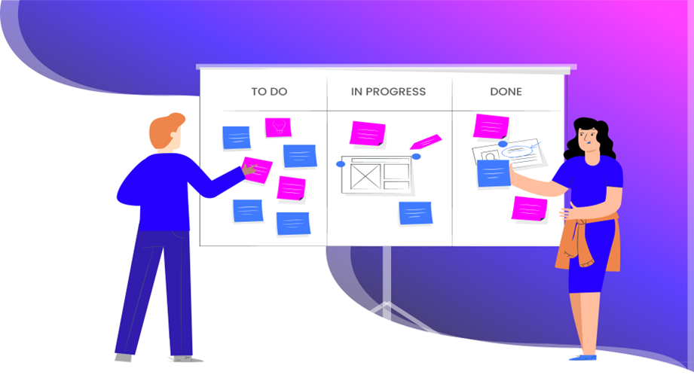  
Figure 2. Agile Kanban Board

# Agile and Project Management Principles and Tools

Principles of Agile Project Management are much in congruence with library and online information center culture and project management. Work structures and processes are similar - logical, methodical, measurable and specific. When dealing with public, special or academic libraries’ online IT projects, needed methodologies are those that provide analytic benchmarks and a measured review of methods and the agility to pivot as needs demand. Many library system migrations, web and mobile redesigns or implementation projects linger too long without progress or, alternatively, are unnecessarily delayed by ‘scope creep,’ the tendency for project requirements to expand until project failure becomes inevitable (Schwalbe, 2011, p.197). All too often, discussion and communication enabling project progress of library systems IT projects breaks down among larger stakeholder groups.

Agile Project Management principles, such as iterative development and simplified workflow management systems, such as Scrum and Kanban, provide tools to prevent scope creep and enable communication, project completion and success. Tools such as defined work breakdown structures (WBS) and stakeholder agreement documents from project management, capture, control and move projects forward in organized and prescribed ways. More specific principles of Agile such as continuous improvement, prompt delivery, minimum viable products, sustainable development and lean thinking synergistically complement more general frameworks of project management to fit more technocentric societal expectations and current ways of development (See Table 1 below).



# Working Methodologies: Scrums, Sprints & Kanban

Scrum is an Agile framework that emphasizes iterative development, self-organizing teams, and continuous delivery. Scrum projects are managed in Sprints, which are time-boxed periods of 1-4 weeks, during which a set of tasks are completed, and Minimal Viable Product (MVP) is produced. At the end of each Sprint, the team reviews the progress made and adjusts the project plan accordingly. Scrum is a highly flexible methodology that can be adapted to a wide range of projects and teams.

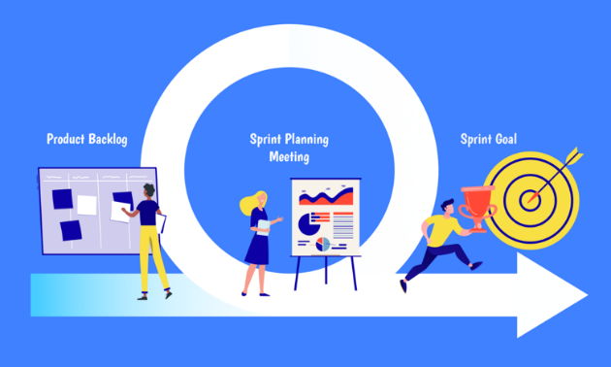

*Figure 3. Scrum and Sprint Planning*

Scrum can be applied to library IT projects in a variety of ways. For example, a library may use Scrum to develop a new digital library platform. The project team would be organized into a self-organizing Scrum team that would work together to develop the platform in Sprints. The team would meet regularly to discuss progress, identify roadblocks, and adjust as needed. By using Scrum, the library could respond to changes in the project quickly and deliver a high-quality product on time.

Kanban is an Agile methodology that emphasizes visualizing work, limiting work in progress, and delivering work in a continuous flow. Kanban projects are managed through a Kanban Board, which is a visual representation of the work being done. The Kanban Board is divided into columns, each of which represents a stage of the project. As work is completed, each activity is moved to the next column on the board. Kanban can be applied to library IT projects in a variety of ways. For example, a library may use Kanban to manage the development of a new mobile application. The project team would use a Kanban Board to visualize the work ‘To Do,’ ‘Being Done’ and ‘Done.’ As work is completed, it will be moved to the next board. Trello is a notable example of an online Kanban Board which also emphasizes socially networked online communication.

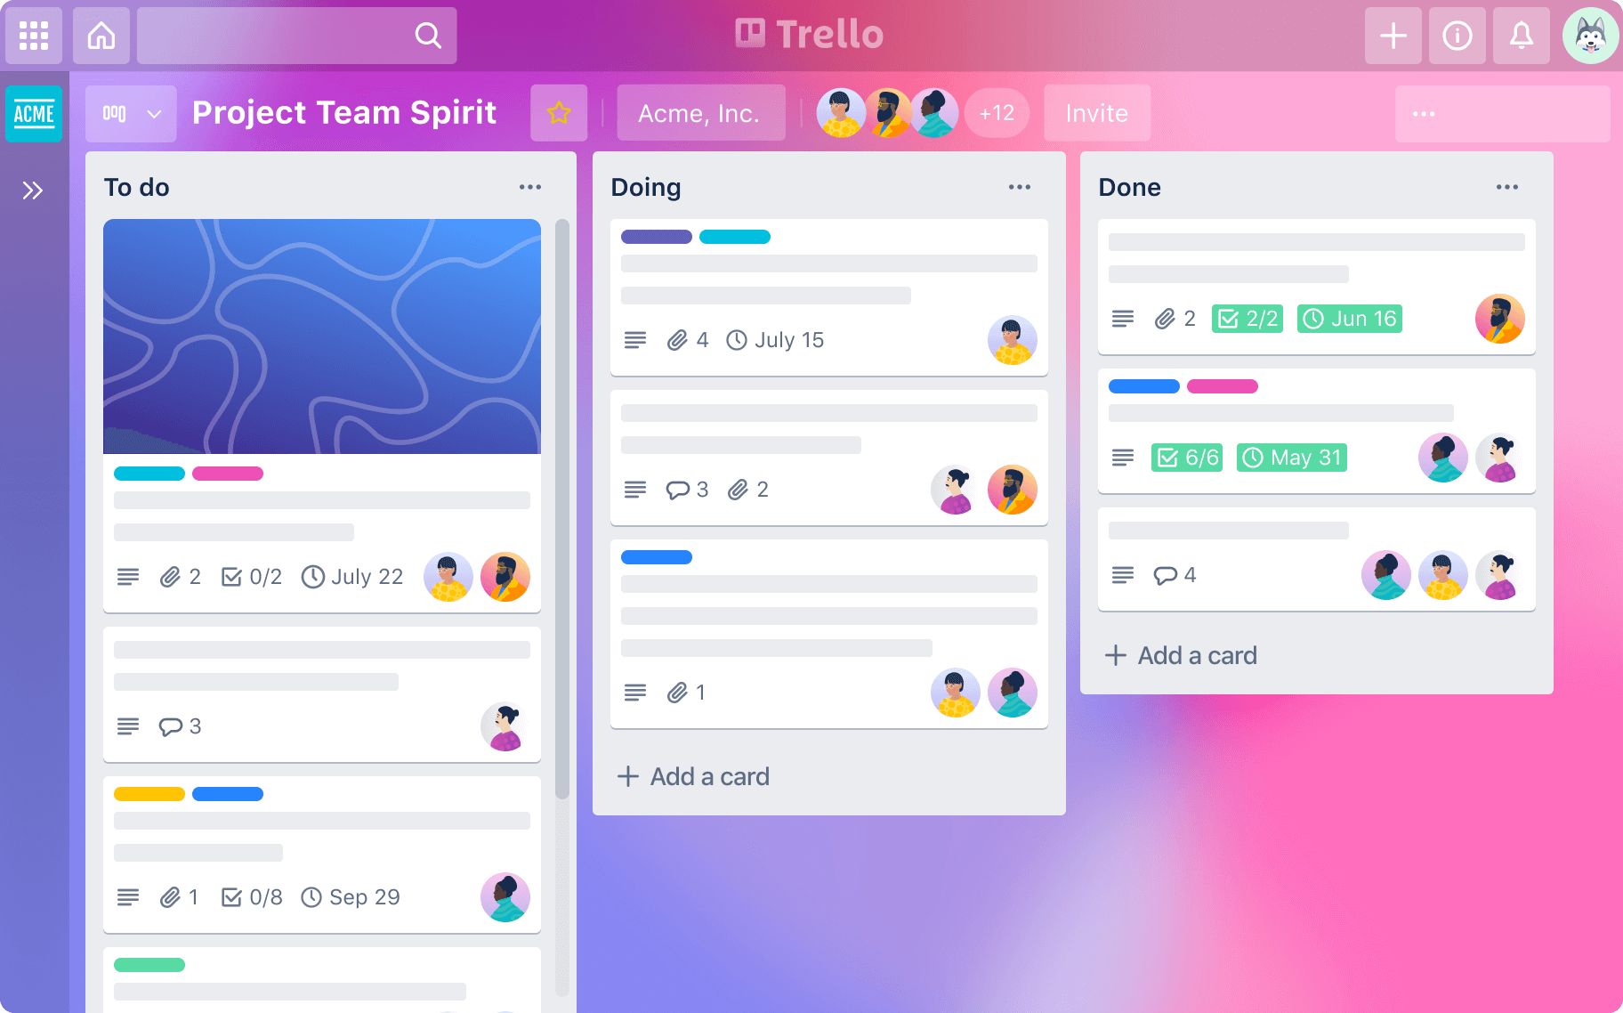  
*Figure 4. Trello Kanban Board.* [*https://www.atlassian.com/software/trello*](https://www.atlassian.com/software/trello)

# Libraries, Communication, Project Management Methodologies

The major cause for any IT project failure or delay during a project lifecycle is communication breakdowns and a lack of planning by stakeholders (IT Cortex, 2008). This failure of planned communication and the need for risk management methodologies is magnified in large institutions like libraries. Typically, a variety of stakeholders are tasked to implement or redesign new technological artifacts whether these be new mobile websites, digital libraries or implementation of enterprise-wide information systems. Usually, many of the team stakeholders tasked with these projects will have little IT experience and less formal project management training. This legacy of historical library workplace development becomes a detriment and liability. The irony is that from Agile Project Management contexts, this diversity may be harnessed towards better usability review, communication and systems. Fair to say, communication breakdowns with these heterogeneously composed teams or committees happen often. Agile Project Management tools like Kanban boards simplify, formalize and manage communication channels through ‘communication’ planning and documents inclusive of stakeholder registries and management strategies.

# The Business Case for Agile IT Project Managers

Tasking a project manager to formalize communications through a project lifecycle to manage stakeholder expectations facilitates buy-in and ownership of a project, monitors and controls stakeholder processes and results in more efficient decision making for subsequent milestones for greater chance of success (Masses, 2010, p. 529). One of the key issues a digital library project manager must currently contend with has to do with how to shepherd projects towards approval and the top of the queue for competing resources. In terms of human resources and with the ever-expanding agenda of projects, a passionate library IT project manager on staff is also a clever idea whose time has arrived.

Agile Project management also offers both structured software and quantification possibilities for both formalization of project metrics and structured analytics for later assessment (Microsoft Project) but also more agile-minded communication tools for quick global communications (i.e., Basecamp, Monday.com, Atlassian’s Jira). From Agile Project Management perspectives, library IT projects, whether additions to the system, new systems, or specialized digital library requests, are also disruptive forces which frequently encounter a variety of resistance.

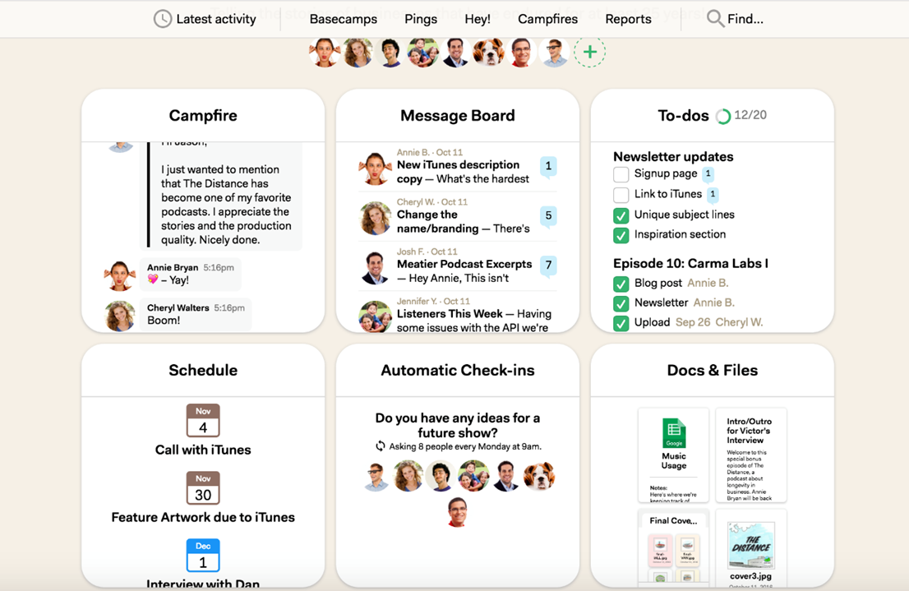  
Figure 5. Basecamp Communication & Collaboration Tools

Library IT project managers should create wide fields of allies as early as possible through appeals to common organizational objectives and mission statements (Cervone, 2011, p.96). Formalizing communication lines with online library IT project stakeholders, library organizational leaders and university representatives is also a good first step. Transparently discussing issues relating to resistance and thinking through group psychology is a good proactive Agile Project Management technique and may be usefully formalized within online library project work plans. Identifying preferred communication vehicles, stakeholder viewpoints and varying levels of commitment or resistance potentially helps meetings and communications planning and forwarding a project with larger organizations. Communication and social media design plans are key, including strategizing with team members regarding the target project communications that will be sent to specific constituent groups who may be particularly invested or resistant to a project.

# Approaching Agile IT Projects – Sponsors, Scope, and Agile Developmental Models

Many libraries’ IT projects, even major ones, are started without a project sponsor, plan, project manager or formalized methodology. To be Agile, one should not discard project management plans. A project plan is still needed to provide a roadmap which should include scope statements, deliverables and team information. A communication plan, work breakdown structure, controlling mechanisms and a budget should be included and documents should be transparent and circulated with higher administration for initial project sponsorship, review and support.

If one is developing any type of digital library application or mobile infrastructure, a software development methodology should be chosen. All too often, library IT projects fail to formalize these methods to the project’s peril. Information technology project development models also range in style and methodology, each having specific characteristics. Waterfall, incremental, iterative, adaptive and exploratory are all common Agile development models, each possessing specific characteristics and suitability towards different environments (Schwalbe, 2011, p. 59- 61). Project stakeholders should be aware of conceptual model parameters including timelines and basic characteristics.

An Agile approach to IT project development includes the progressive strategy of scope, design, build, test, check and deploy, with a quick initial iteration development time termed a Sprint (usually around four weeks). This allows design and redesign of the system based on user feedback (Chang, 2010, p.673). With this methodology, emphasis is on gathering requirements in a project plan in a clear, complete and verifiable way (Chang, p. 673).

It is also important that stakeholders are aware of the methodology and have also signed a project plan to understand parameters to increase chances for project success. Project managers should also be aware of differences in methodology to suit the various library environments. Agile methods work best in organizational cultures where change is welcome and innovation and creativity are encouraged with less resistance (Chang, p. 677). If a project manager becomes cognizant that the wider environment is not suitable for this type of IT methodology, it is their duty to shift methodologies or educate proactively to a more suitable method for the culture.

# Agile Library Project Managers: The Current Landscape

Presently, the role of a dedicated IT project manager with an Agile or PMP designation in academic, public or special libraries is still relatively rare, but these methodologies are increasingly accepted. As mid and large-scale technology project demands for libraries have increased, the time has come to bring this staff employment category into the fold or, alternatively, lobby to include a concentration of IT Agile and project management courses in traditional Master of Library and Information Science Graduate Degrees (MLIS). A longer list of formal Agile techniques of Kanban, Lean and Scrum, as well as project management inclusive of writing project plans, controlling scope, identifying sponsors, documenting project requirements and budgets have large room within library IT projects. A good, steadfast project manager and formal communication plan between stakeholders and administration enables a well-planned setting for more creative parameters and technical progress. Library IT projects would also benefit from a dedicated agile library project manager to clarify shifting priorities (scope creep), address resource issues, plan communications and formalize technical parameters (Fan and Keach, 2011, p.12).

Figure 6. Monday.com Project Overview Kanban Board Variation

# Libraries Changing 21st Century Goals

In a survey of libraries going forward in the early twenty-first century, the Institute of Museum and Library Services (IMLS) found that the highest priority goal of academic libraries was ranked as increased access to collections through digitization. The second highest priority was named as preservation of materials through digitization and digital projects (Lopatin, 2006, p.274). Both priorities, even more so today, involve ongoing elevated levels of IT project commitment and agile management techniques. Many libraries involve special collections whose main thrust in the 21st century regard specialized, born-digital and most recently mixed media extended reality (XR) and AI assisted classification projects. These projects may be large or small scale, textual or image based. They involve a complex amalgam of text, multimedia artifacts and data and a wide range of stakeholders with varying needs and agendas. IT project requirements are increasingly complex. Because of the contents’ increased level of media, copyright and metadata complexity, librarians have more than enough on their section of this plate. With ongoing complex IT platform delivery expectations (mobile, etc.), the addition of Agile project management organization skills toward these multi-pronged projects allows for the focus of specialized skills through the segmentation of roles.

# Conclusions, Agile and Library AI Projects

The upcoming possibilities for libraries and AI technologies in the 21st century with regards to Agile, services, content and the currently occurring AI revolution are fascinating, vibrant, and complex. Agile IT Project Management will play a vital role in emergent AI categories of patron services engendered, applications created and how the ever-growing stream of digital content is managed, processed, labelled with metadata, and then retrieved.

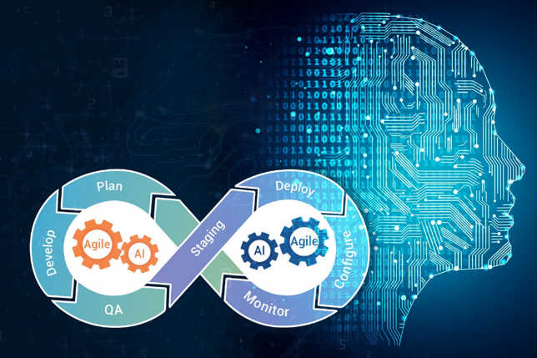  
Figure 7. Agile Iterative Development, Versioning and AI

Project Management with Agile is an imperative area for libraries to reexamine from infrastructure perspectives as they wade into the new paradigms of artificial intelligence. Agile will allow libraries to function and adapt effectively and for institutions to lead with technology. There is also enough room for everyone at the table. Together, stakeholders may work more productively for the more efficient functioning of the greater whole.

This research has rearticulated some of the specificity and challenges of library IT functions, importance, and applicability of principles of Agile Project Management to the field. The application of formalized Agile Project Management for libraries is currently largely unexplored. Major factors of Agile such as continuous integration, prioritization, collaboration, user satisfaction, embracing change, incremental delivery, self-organizing teams have much room for further implementation in libraries. The territory for synthesis of agile with library, information science, AI and IT project management is fertile. Hopefully, this research has pointed out a few of the salient areas, utility, and needs. The future and better success of libraries in the new millennia will depend on the application of 21st century Agile Project Management techniques to the ever- growing complexity of exciting and new AI and other IT project possibilities.

References

Agile Connection. (2023). Lean and Kanban Agile Techniques. https://www.agileconnection.com/topics/lean-kanban

Allan, B. (2004), Project Management: Tools and Techniques for Today's ILS Professional. Facet: London, UK.

Ambler, S. W. (2009). Agile project management for information technology. Information Management & Computer Security, 17(1), 5-12. doi: 10.1108/09685220910938337.  
  
 Atlassian. (2023) Atlassian’s No-Nonsense Guide to Agile Development. https://www.atlassian.com/agile

Bartlett, J. (Fall 2011). Project management in libraries, archives and museums. Reference Quarterly. 51(1). 87-88.

Basecamp (2023). Project Management Software. 37 Signals. https://basecamp.com/

Beck, et al. (2022). What is the Agile Manifesto. Agile Alliance. https://www.agilealliance.org/agile101/the-agile-manifesto/

Bloomberg Originals. (2018). Agile History: How Toyota Changed the Way We Make Things. YouTube Video: https://www.youtube.com/watch?v=F5vtCRFRAK0

Carpenter, J. (2010). Project Management in Libraries, Archives and Museums: Working with government and other external partners. Chandos, Cambridge, UK

Cervone, H.F (2008). Developing a business case for a digital library project. OCLC Systems and Services. 24:1. 18-21.

--- (2011). Overcoming resistance to change in digital library projects. OCLC Systems and Services. 27:2. 95-98.

Chang, May (2010). An agile approach to library IT innovation. Library High Tech. 28:4. 672-689.

Fagan, J.C. and Keach J. (2011) Managing web projects in academic libraries. Library Leadership and Management. 25:3. pp. 1-23.

Harirajan, Praveen. (2023). Fractal Analytics. (2023). Applying the Agile Methodology to Artificial Intelligence and Machine Learning Projects. https://nealanalytics.com/blog/applying-the-agile-methodology-to-ai-ml-projects/

HPT Agile. (2020). History of Agile and Lean. YouTube Video: https://www.youtube.com/watch?v=WKIy8nssMQc

Horwath, J.A. (2012), “How Do We Manage? Project Management in Libraries: An Investigation.” Partnership: The Canadian Journal of Library and Information Practice and Research. 7:1

IEEE Standard 105-1998. IEEE Standards Association. Available from: https://standards.ieee.org/findstds/standard/1058-1998.

IT Cortex (2008). Project failure statistics. IT-cortex.com Retrieved from http://www.it- cortex.com/Stat_Failure_Cause.htm

Klapwijk, Wouter (January 2023). Applying Agile Principles for ICT Operations Management in an Academic Library Setting. [Trends and Issues in Library Technology](https://www.researchgate.net/publication/366702047_Trends_and_Issues_in_Library_Technology_AI_Cultural_Heritage_Open_Science): IFLA.

Lopatin, L (2006). Library digitization projects: issues and guidelines. Library Hi Tech.24:2. 273-289

Massis, B (2010). Project management in the library. New Library World. 111:11/12. 526-529.

Monday.com (2023). Visual Work Management Agile Tools. https://monday.com/product

Schwalbe, K. (2011). Information technology project management (6th ed.). Boston, MA: Cengage Learning Course Technology.

Trello (2023). Visual Project Management. Atlassian. https://trello.com/home

Schwaber, Ken, and Jeff Sutherland. (2023) “The Scrum Guide." Scrum.org. Accessed April 8, 2023. <https://www.scrum.org/resources/scrum-guide>.

Uzwyshyn R. (ed.) et al. (June, 2023), Chilton G., Gendreau et al., Yon, A. Trends and Issues in Library Technology: [Special Issue on Agile Project Management](https://www.researchgate.net/publication/370838195_Trends_and_Issues_in_Library_Technology_Agile_Project_Management).

Weerakoon, Sameera. (2019) How Japanese Manufacturing Influenced Agile: A Brief Explanation on Scrum vs. Kanban. Medium. https://sameera17w.medium.com/how-japanese-manufacturing-influenced-agile-a-brief-explanation-on-scrum-vs-kanban-c7962c63ef64