**Can We Get Some Agile Here? The Application of Agile Project Management Principles for Library IT**

**Ray Uzwyshyn, Ph.D. MLIS MBA,** [**ruzwyshyn@gmail.com**](mailto:ruzwyshyn@gmail.com) **Associate Dean, Research Collections and Strategy  
Mississippi State University Libraries**



Figure 1. Agile Project Management

**Introduction – Libraries and Principles of Agile Project Management**

As we enter the second decade of the 21st century, our institutions are rapidly changing. Agile project management techniques are needed to pivot with modern technology paradigms and take advantage of new library possibilities. Academic libraries are no exception to these shifts with an increasing range of complex IT implementation expectations through rosters of IT projects ranging from technology enhanced learning commons, to data research repositories, AI and new Algorithmic literacy centers. To manage the pace of new IT implementation and ongoing integration demands, a structured and Agile application of principles of IT project management is warranted. This research explores an innovative line of Agile 21st century IT project management principles for online library projects under the rubrics of Agile and Project Management. This includes collaboration, iteration, user focus, flexibility, emergence and embracing versioning for quick empowerment of decision-making for greater innovation. This work focuses particularly on the logistics of Agile management that online library projects more desperately need. It explains the case for Agile projects to highlight the necessity for Agile implementation through principles and the wider scope of project management.

Agile IT Project Management is a methodology for managing IT projects that emphasizes iterative development, collaboration, and responsiveness to change. Key concepts include user focus, adaptive planning, continuous delivery, and self-organizing teams (Ambler, 2009). Agile Project Management concepts find applicability in academic libraries where processes could benefit from streamlining through a formalization of Agile Project Management structures and processes. Scrum, Kanban and Lean are frameworks, structures and methodologies that all benefit Library IT processes. Even though system wide implementation of information technology has been carried out widely in libraries in the past three decades, there is room for a more structured approach utilizing these structures from Agile perspectives. This research highlights a few current directions and synergies from best practices of Agile Project Management and current library technology needs. It highlights the most applicable and innovative areas of agile techniques that would be useful to pursue.

**Agile and Project Management Principles and Tools**

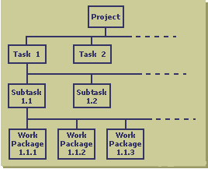  
Figure 2. Work Breakdown Structure

Principles of Agile Project Management are much in congruence with library and online information center culture and project management. Work structures and processes are similar - logical, methodical, measurable and specific. When dealing with public, special or academic libraries’ online IT projects, needed methodologies are those that provide analytic benchmarks and a measured review of methods and the agility to pivot as needs demand. Many library system migrations, web and mobile redesigns or implementation projects linger too long without progress or, alternatively, are unnecessarily delayed by ‘scope creep,’ the tendency for project requirements to expand until project failure becomes inevitable (Schwalbe, 2011, p.197). All too often, discussion and communication enabling project progress of library systems IT projects breaks down among larger stakeholder groups. Agile Project Management principles, such as iterative development and simplified workflow management systems, such as Scrum and Kanban, provide tools to prevent scope creep and enable communication, project completion and success. Tools such as defined work breakdown structures (WBS) and stakeholder agreement documents from project management capture, control and move projects forward in organized prescribed ways. More specific principles of Agile such as continuous improvement, early delivery, minimum viable products, sustainable development and lean thinking synergistically complement more general frameworks of project management to fit more technocentric societal expectations and current ways of development (See Table 1).

| **Principles of Agile IT Project Management** | **Definition** | **Example 1** | **Example 2** | **Additional Examples** |
| --- | --- | --- | --- | --- |
| **User Satisfaction** | Delivering valuable software that meets user needs | Delivering a product that meets user expectations | Gathering and incorporating feedback from end-users throughout development | Conducting user surveys to assess satisfaction |
| **Embracing Change** | Responding to change in requirements, priorities, and market conditions | Prioritizing features based on changing business needs | Incorporating feedback and insights from stakeholders to improve the product | Updating the product roadmap based on changing market conditions |
| **Incremental Delivery** | Delivering working software in small, incremental releases | Releasing a minimum viable product to test and validate assumptions | Delivering new features in small, frequent releases to provide value to users | Updating and refining the product backlog based on feedback from users and stakeholders |
| **Self-Organizing Teams** | Teams that have the authority and responsibility to organize themselves and make decisions | Empowering team members to choose how they work and what they work on | Encouraging team members to take ownership of the development process | Facilitating collaboration and knowledge sharing among team members |
| **Continuous Improvement** | Fostering a culture of continuous learning and improvement | Conducting regular retrospectives to identify areas for improvement | Experimenting with new tools, processes, and methodologies to improve productivity | Encouraging open and honest communication and feedback among team members |
| **Agile Planning** | Emphasizing flexibility and responsiveness in planning and prioritization | Using an iterative planning process to refine and prioritize development tasks | Prioritizing development tasks based on business value and user needs | Creating a product roadmap to align development efforts with business goals |
| **Early and Continuous Delivery** | Delivering working software as early and frequently as possible | Releasing a minimum viable product to test and validate assumptions | Delivering new features in small, frequent releases to provide value to users | Using continuous integration and delivery to ensure the product is always in a deployable state |
| **Working Software** | Emphasizing the importance of delivering working software that meets user needs | Prioritizing development tasks based on their impact on delivering working software | Using automated testing to ensure that software is working correctly | Prioritizing technical excellence to ensure that software is maintainable and scalable |

Table 1. Agile Principles of Agile IT Project Management

**Working Methodologies  
  
Scrums and Sprints**

Scrum is an Agile framework that emphasizes iterative development, self-organizing teams, and continuous delivery. Scrum projects are managed in Sprints, which are time-boxed periods of 1-4 weeks, during which a set of tasks are completed, and Minimal Viable Product (MVP) is produced. At the end of each Sprint, the team reviews the progress made and adjusts the project plan accordingly. Scrum is a highly flexible methodology that can be adapted to a wide range of projects and teams.

Scrum can be applied to library IT projects in a variety of ways. For example, a library may use Scrum to develop a new digital library platform. The project team would be organized into a self-organizing Scrum team that would work together to develop the platform in Sprints. The team would meet regularly to discuss progress, identify roadblocks, and adjust as needed. By using Scrum, the library could respond to changes in the project quickly and deliver a high-quality product on time.  
  
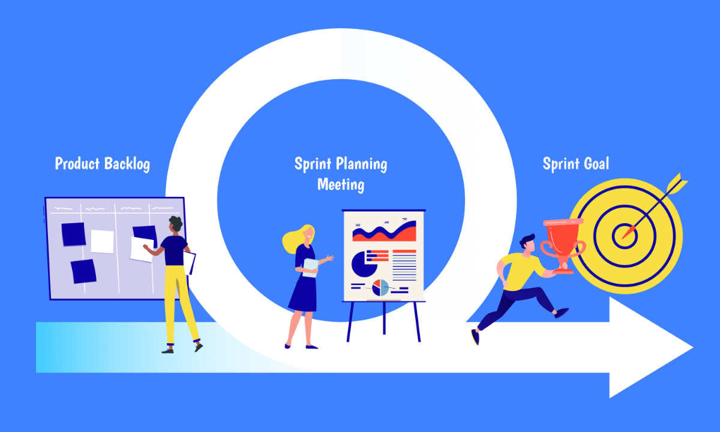  
Figure 3. Scrum and Sprint Planning

**Kanban and Kanban Boards**

Kanban is an Agile methodology that emphasizes visualizing work, limiting work in progress, and delivering work in a continuous flow. Kanban projects are managed through a Kanban Board, which is a visual representation of the work being done. The Kanban Board is divided into columns, each of which represents a stage of the project. As work is completed, each activity is moved to the next column on the board.  
  
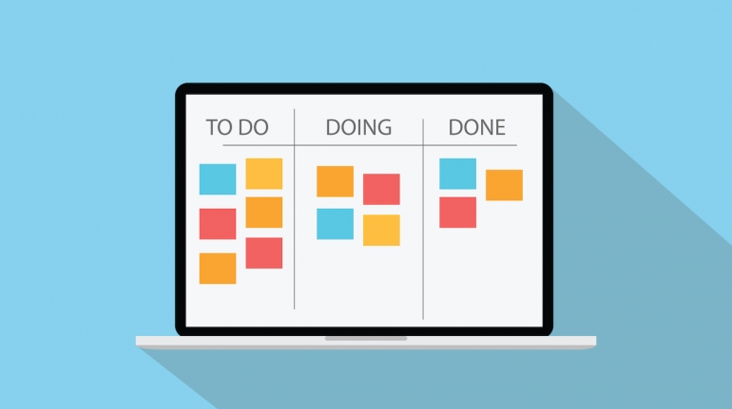  
Figure 4. Kanban Simplified Board

Kanban can be applied to library IT projects in a variety of ways. For example, a library may use Kanban to manage the development of a new mobile application. The project team would use a Kanban Board to visualize the work ‘To Do,’ ‘Being Done’ and ‘Done.’ As work is completed, it will be moved to the next board. Trello is a notable example of an online Kanban Board which also emphasizes socially networked online communication.  
  
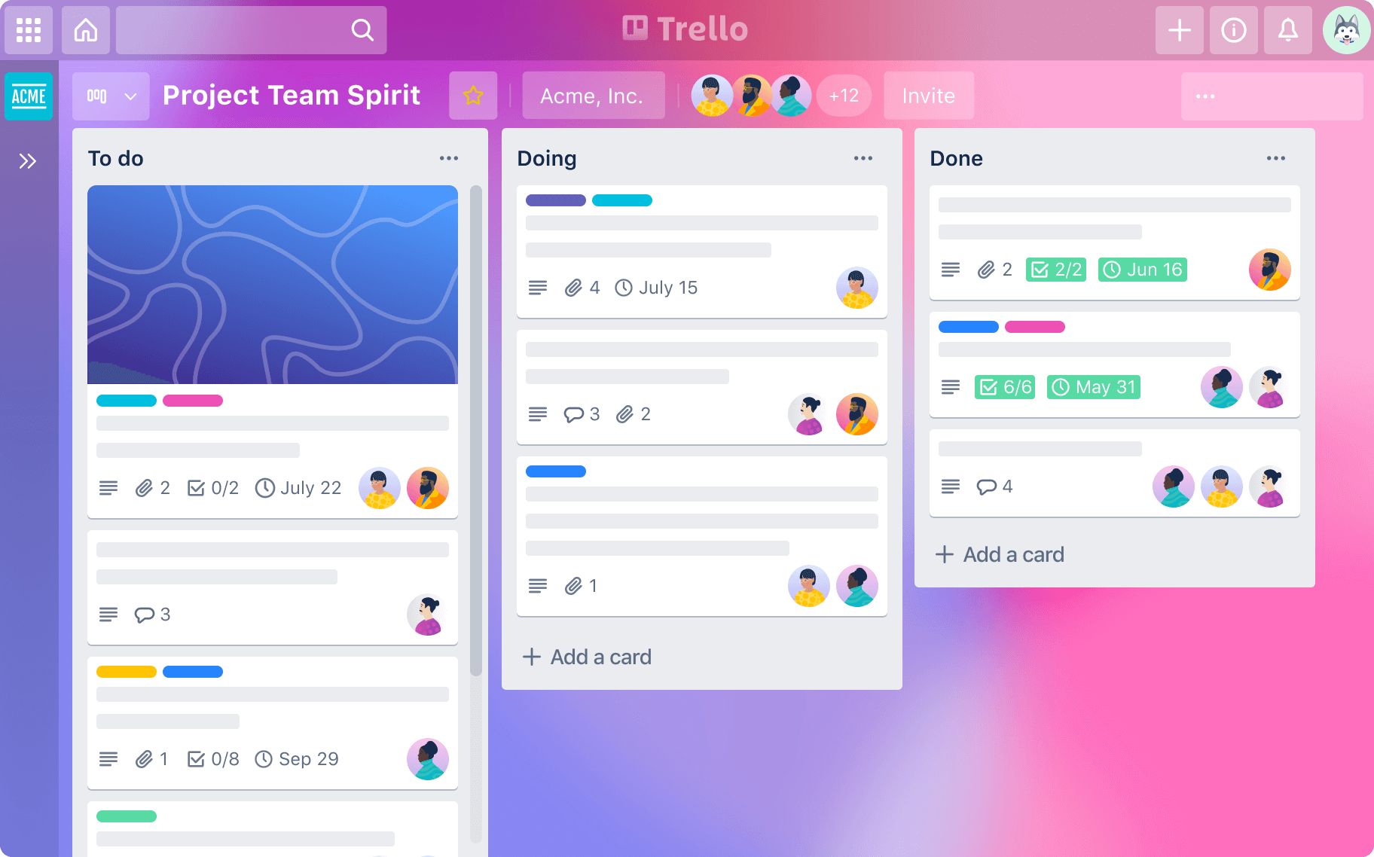  
Figure 5. Trello Kanban Board. https://www.atlassian.com/software/trello

**Libraries, Communication, Project Management Methodologies**

The major cause for any IT project failure or delay during a project lifecycle is communication breakdowns and a lack of planning by stakeholders (IT Cortex, 2008). This failure of planned communication and the need for risk management methodologies is magnified in large institutions like libraries. Typically, a variety of stakeholders are tasked to implement or redesign new technological artifacts whether these be new mobile websites, digital libraries or implementation of enterprise-wide information systems. Usually, many of the team stakeholders tasked with these projects will have little IT experience and less formal project management training. This legacy of historical library workplace development becomes a detriment and liability. The irony is that from Agile Project Management contexts, this diversity may be harnessed towards better usability review, communication and systems. Fair to say, communication breakdowns with these heterogeneously composed teams or committees happen often. Agile Project Management tools like Kanban boards simplifies, formalizes and manages communication channels through ‘communication’ planning and documents inclusive of stakeholder registries and management strategies.

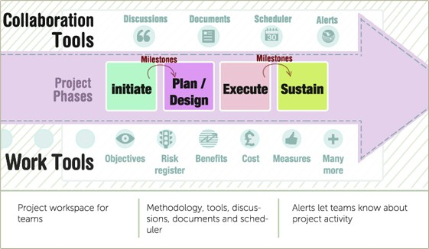

Figure 6. Communication Channels Through Collaboration Work Tools

**The Business Case for Agile IT Project Managers**

Tasking a project manager to formalize communications through a project lifecycle to manage stakeholder expectations facilitates buy-in and ownership of a project, monitors and controls stakeholder processes and results in more efficient decision making for subsequent milestones for greater chance of success (Masses, 2010, p. 529).

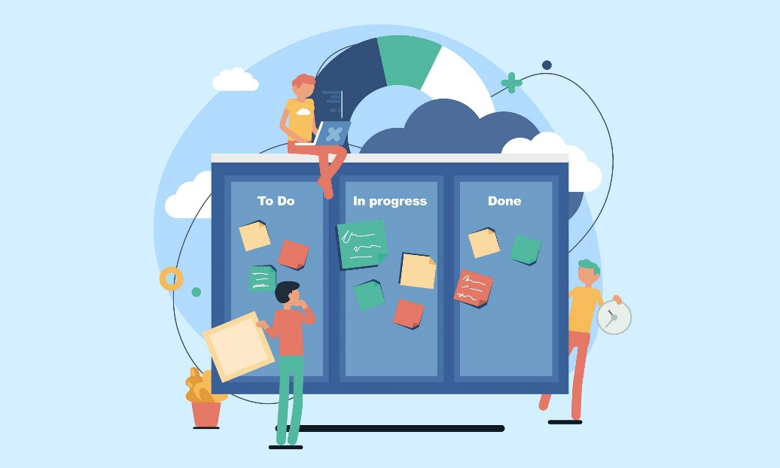  
Figure 7. Project Managers and Kanban to Simplify Workflow Complexity

One of the key issues a digital library project manager must currently contend with has to do with how to shepherd projects towards approval and the top of the queue for competing resources. In terms of human resources and with the ever-expanding agenda of projects, a passionate library IT project manager on staff is also a clever idea whose time perhaps has arrived.

Agile Project management also offers both structured software and quantification possibilities for both formalization of project metrics and structured analytics for later assessment (Microsoft Project) but also more agile-minded communication tools for quick global communications (i.e. Basecamp, Monday.com, Atlassian’s Jira). From Agile Project Management perspectives, library IT projects, whether additions to the system, new systems or specialized digital library requests, are also disruptive forces which frequently encounter a variety of resistance.

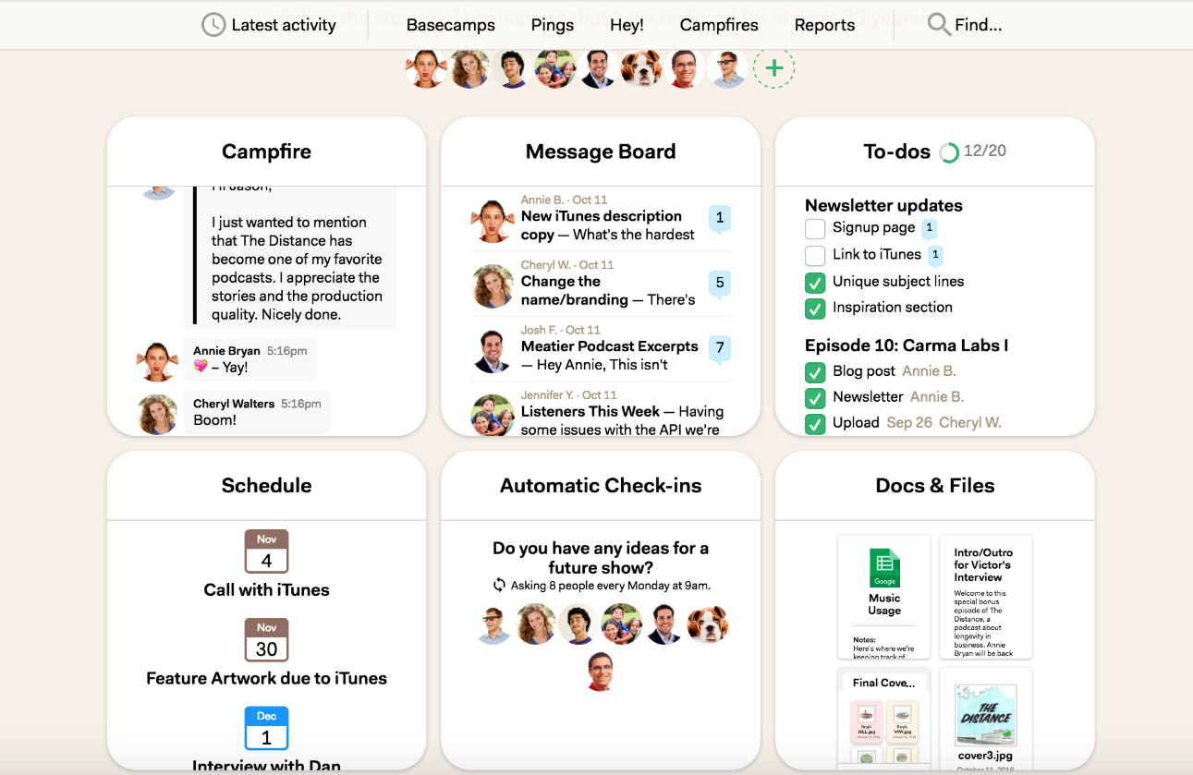

Figure 8. Basecamp Communication & Collaboration Tools

Library IT project managers should create wide fields of allies as early as possible through appeals to common organizational objectives and mission statements (Cervone, 2011, p.96).   
  
Figure 9. Agile Communication Assignment Matrix Techniques  
  
Formalizing communication lines with online library IT project stakeholders, library organizational leaders and university representatives is also a good first step. Transparently discussing issues relating to resistance and thinking through group psychology is also a good proactive Agile Project Management technique and may be usefully formalized within online library project work plans. Identifying preferred communication vehicles, stakeholder viewpoints and varying levels of commitment or resistance potentially helps meetings and communications planning and forwarding a project with larger organizations. Communication and social media design plans are key, including strategizing with team members regarding the target project communications that will be sent to specific constituent groups who may be particularly invested or resistant to a project.

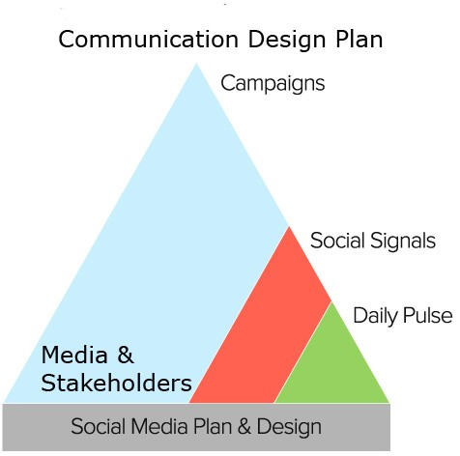

Figure 10. Communication and Social Media Design Plans

**Approaching Agile IT Projects – Sponsors, Scope, and Agile Developmental Models**

Many libraries’ IT projects, even major ones, are started without a project sponsor, plan, project manager or formalized methodology. To be Agile, one should not discard project management plans. A project plan is still needed to provide a roadmap which should include scope statements, deliverables and team information. A communication plan, work breakdown structure, controlling mechanisms and a budget should be included and documents should be transparent and circulated with higher administration for initial project sponsorship, review and support.

If one is developing any type of digital library application or mobile infrastructure, a software development methodology should be chosen. All too often, library IT projects fail to formalize these methods to the project’s peril. Information technology project development models also range in style and methodology, each having specific characteristics. Waterfall, incremental, iterative, adaptive and exploratory are all common Agile development models, each possessing specific characteristics and suitability towards different environments (Schwalbe, 2011, p. 59- 61). Project stakeholders should be aware of conceptual model parameters including timelines and basic characteristics.

An Agile approach to IT project development includes the progressive strategy of scope, design, build, test, check and deploy, with a quick initial iteration development time termed a Sprint (usually around four weeks). This allows design and redesign of the system based on user feedback (Chang, 2010, p.673). With this methodology, emphasis is on gathering requirements in a project plan in a clear, complete and verifiable way (Chang, p. 673).

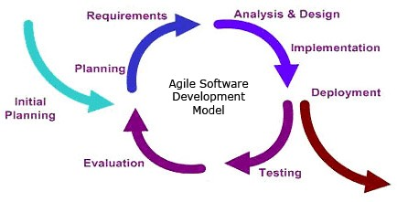Figure 11. Agile Software Development Model

It is also important that stakeholders are aware of the methodology and have also signed a project plan to understand parameters to increase chances for project success. Project managers should also be aware of differences in methodology to suit the various library environments. Agile methods work best in organizational cultures where change is welcome and innovation and creativity are encouraged with less resistance (Chang, p. 677). If a project manager becomes cognizant that the wider environment is not suitable for this type of IT methodology, it is their duty to shift methodologies or educate proactively to a more suitable method for the culture.  
  
**Library IT Agile Project Managers: The Current Landscape**

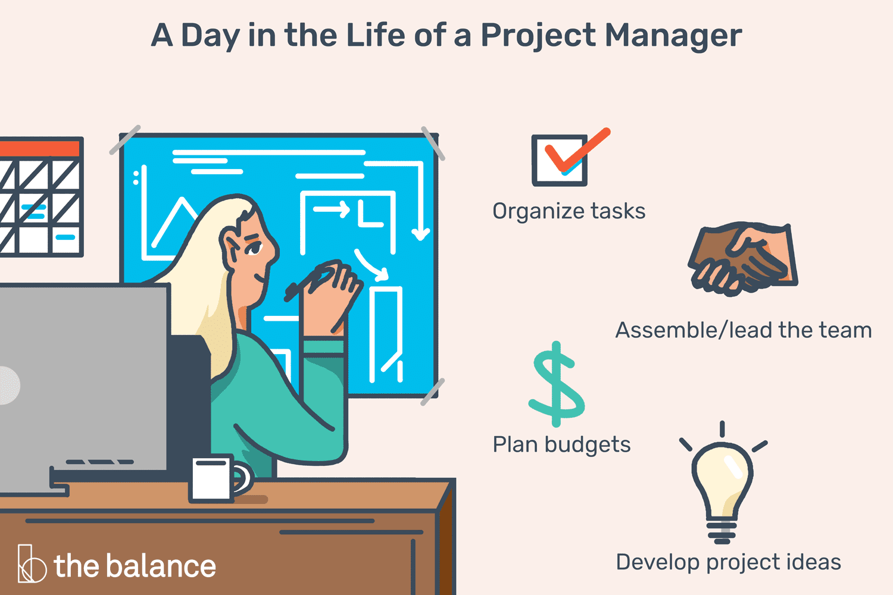

Figure 12. Project Management Formalization

Presently, the role of a dedicated IT project manager with an Agile or PMP designation in academic, public or special libraries is still relatively rare, but these methodologies are increasingly accepted. Often, most library IT projects are managed by librarians with MLIS or IT related degrees from either library, web or systems departments (53%) (Fan and Keach, 2011, p. 6). As mid and large-scale technology project demands for libraries have increased, the time has come to bring this staff employment category into the fold or, alternatively, lobby to include a concentration of IT project management courses in traditional Master of Library and Information Science Graduate Degrees (MLIS).

A longer list of formal Agile techniques of Kanban, Lean and Scrum, as well as project management inclusive of writing project plans, controlling scope, identifying sponsors, documenting project requirements and budgets have large room within library IT projects. A good, steadfast project manager and formal communication plan between stakeholders and administration enables a well-planned setting for more creative parameters and technical progress. Library IT projects would also benefit from a dedicated library project manager to clarify shifting priorities (scope creep), address resource issues, plan communications and formalize technical parameters (Fan and Keach, 2011, p.12).

Figure 12. Monday.com Project Overview Kanban Board Variation

**Libraries Changing 21st Century Goals**

In a survey of libraries going forward in the twenty-first century, the Institute of Museum and Library Services (IMLS) found that the highest priority goal of academic libraries was ranked as increased access to collections through digitization. The second highest priority was named as preservation of materials through digitization and digital projects (Lopatin, 2006, p.274). Both priorities involve ongoing elevated levels of IT project commitment and agile management techniques.

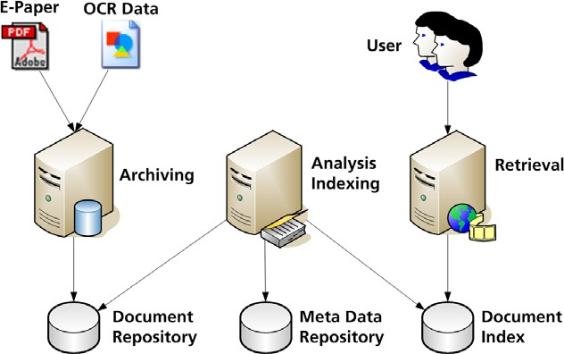Figure 13. Digitization Process  
  
Many libraries involve special collections whose main thrust in the 21st century regard specialized, born-digital and more recently mixed media XR projects. These projects may be large or small scale, textual or image based. They involve a complex amalgam of multimedia artifacts and a wide range of stakeholders with varying needs and agendas. IT project requirements are increasingly complex. Because of the contents’ increased level of media, copyright and metadata complexity, librarians have more than enough on their section of this plate. With ongoing complex IT platform delivery expectations (mobile, etc.), the addition of Agile project management organization skills toward these multi- pronged projects allows focus of specialized skills through segmentation of roles.

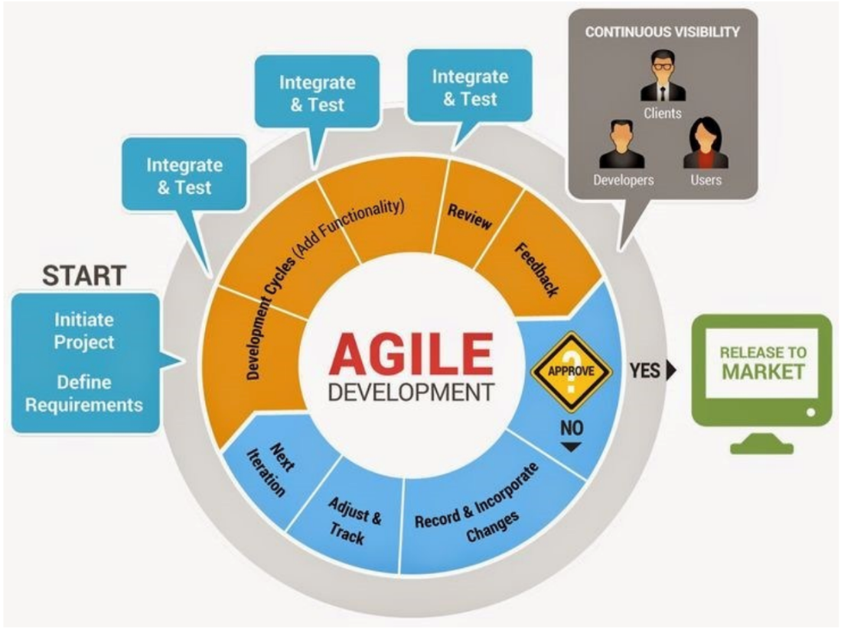

Figure 14. Agile Product Development Cycle

**Conclusions, Agile and Library AI Projects**

The upcoming possibilities for libraries and AI technologies in the 21st century with regards to Agile, services, content and the currently occurring AI revolution are fascinating, vibrant, and complex. Agile IT Project Management will play a vital role in emergent AI categories of patron services engendered, applications created and how the ever-growing stream of digital content is managed, processed, labeled with metadata and then retrieved.

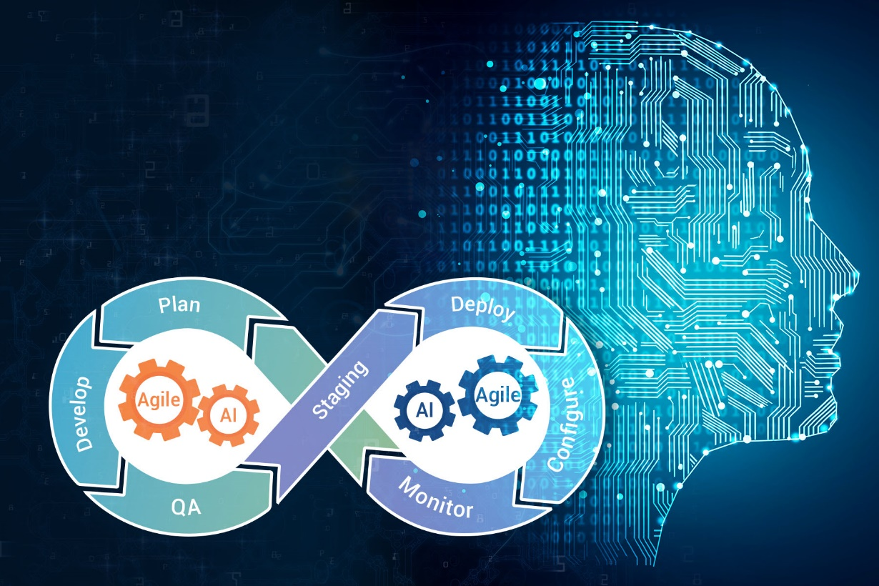

Figure 14. Library AI Projects, Agile and Human Computer Interaction

Project Management with Agile is an imperative area for libraries to reexamine from infrastructure perspectives as they wade into the new paradigms of artificial intelligence. Agile will allow libraries to function and adapt effectively and for institutions to lead with technology. There is also enough room for everyone at the table. Together, stakeholders may work more productively for the more efficient functioning of the greater whole.

This research has rearticulated some of the specificity and challenges of library IT functions, importance, and applicability of principles of Agile Project Management to the field. The application of formalized Agile Project Management for libraries is currently largely unexplored. Major factors of Agile such as continuous integration, prioritization, collaboration, user satisfaction, embracing change, incremental delivery, self-organizing teams (see Table 2) have much room for further implementation in libraries. The territory for synthesis of agile with library, information science, AI and IT project management is fertile. Hopefully, this research has pointed out a few of the salient areas, utility and needs. The future and better success of libraries in the new millennia will depend on the application of 21st century Agile Project Management techniques to the ever- growing complexity of exciting and new AI and other IT project possibilities.

| **Major Factors in Agile IT Project Management** | **Definition** | **Example 1** | **Example 2** | **Additional Examples** |
| --- | --- | --- | --- | --- |
| **Iterative Development** | Continuous improvement through frequent cycles of planning, development, and testing | Scrum framework: An agile framework for software development that emphasizes iterative development and cross-functional teams. | Kanban methodology: A method for managing and improving workflows that emphasizes visualization, limiting work in progress, and continuous delivery. | Lean development practices: A set of principles and practices that focus on eliminating waste, maximizing value, and continuous improvement. |
| **User Involvement** | Collaboration and feedback from end-users throughout the development process | User stories and personas: Techniques for defining user needs and goals that can inform the development process. | Usability testing and user acceptance testing: Techniques for evaluating the usability and effectiveness of software from the perspective of end-users. | Agile UX design methodologies: Approaches to user experience design that prioritize collaboration and iterative feedback. |
| **Cross-Functional Teams** | Multi-disciplinary teams with shared accountability and flexible roles | Self-organizing teams: Teams that have the authority and responsibility to organize themselves and make decisions. | Pair programming and code reviews: Techniques for improving code quality and sharing knowledge across team members. | DevOps and Continuous Delivery: A set of practices and tools that emphasize collaboration and automation between development and operations teams. |
| **Adaptive Planning** | Flexibility and responsiveness to changing requirements and priorities | Backlog grooming and sprint planning: Techniques for refining and prioritizing development tasks based on feedback and changing requirements. | Agile estimation and story point sizing: Techniques for estimating the effort required to complete development tasks, which can inform project planning and prioritization. | Retrospectives and continuous improvement: Techniques for reflecting on the development process and identifying opportunities for improvement. |
| **Time-Boxed Delivery** | Fixed periods of development with deliverables at the end of each cycle | Sprints and iterations: Fixed periods of development that typically last one to four weeks, during which a set of prioritized tasks are completed and delivered. | Time-boxed meetings and ceremonies: Meetings and events that have a fixed duration and schedule, including daily stand-up meetings, sprint planning, and sprint retrospectives. | Release planning and roadmapping: Techniques for planning and coordinating multiple development cycles and releases over a longer timeframe. |
| **Continuous Integration** | Continuous integration of code changes and automated testing | Continuous integration and delivery pipelines: Automated processes for integrating code changes and testing them in a controlled environment before deployment. | Automated unit and acceptance testing: Techniques for automatically testing code at multiple levels to ensure that it meets requirements and performs as expected. | Continuous deployment and monitoring: Techniques for deploying and monitoring software in production environments, which can inform future development and maintenance. |
| **Prioritization** | Prioritization of features and tasks based on business value and user needs | Product backlog management: Techniques for managing and prioritizing a list of development tasks based on business value and user needs. | Value-driven prioritization techniques: Approaches to prioritization that focus on maximizing value and minimizing waste, such as cost of delay analysis and value-based pricing. | Minimum Viable Product (MVP) development: A strategy for developing a product with only the essential features required to test and validate its value to users. |
| **Collaboration** | Collaboration and communication between team members and stakeholders | Daily stand-up meetings: Short, daily meetings in which team members share updates, identify blockers, and coordinate their work. | Retrospectives and feedback sessions: Meetings and events in which team members reflect on their work and identify opportunities for improvement, often with the participation of stakeholders. | Pair programming and code reviews: Techniques for sharing knowledge, improving code quality |

Table 2. Major Factors in Agile IT Project Management

**References**

Agile Connection. (2023). Lean and Kanban Agile Techniques. https://www.agileconnection.com/topics/lean-kanban

Allan, B. (2004), *Project Management: Tools and Techniques for Today's ILS Professional*. Facet: London, UK.

Ambler, S. W. (2009). Agile project management for information technology. Information Management & Computer Security, 17(1), 5-12. doi: 10.1108/09685220910938337.  
  
Atlassian. (2023) Atlassian’s No-Nonsense Guide to Agile Development. https://www.atlassian.com/agile

Bartlett, J. (Fall 2011). Project management in libraries, archives and museums. *Reference Quarterly. 51(1)*. 87-88.

Basecamp (2023). Project Management Software. 37 Signals. https://basecamp.com/

Carpenter, J. (2010). *Project Management in Libraries, Archives and Museums: Working with government and other external partners.* Chandos, Cambridge, UK

Cervone, H.F (2008). Developing a business case for a digital library project. *OCLC Systems and Services. 24:1*. 18-21.

--- (2011). Overcoming resistance to change in digital library projects. *OCLC Systems and Services. 27:2*. 95-98.

Chang, May (2010). An agile approach to library IT innovation. *Library High Tech. 28:4*. 672-689.  
  
Fagan, J.C. and Keach J. (2011) Managing web projects in academic libraries. *Library Leadership and Management. 25:3*. pp. 1-23.

Harirajan, Praveen. (2023). Fractal Analytics. (2023). Applying the Agile Methodology to Artificial Intelligence and Machine Learning Projects. https://nealanalytics.com/blog/applying-the-agile-methodology-to-ai-ml-projects/  
  
Horwath, J.A. (2012), “How Do We Manage? Project Management in Libraries: An Investigation.” Partnership: The Canadian Journal of Library and Information Practice and Research. 7:1.

IEEE Standard 105-1998. IEEE Standards Association. Available from: https://standards.ieee.org/findstds/standard/1058-1998.  
  
Monday.com (2023). Visual Work Management Agile Tools. https://monday.com/product

IT Cortex (2008). Project failure statistics. IT-cortex.com Retrieved from http://www.it- cortex.com/Stat_Failure_Cause.htm

Lopatin, L (2006). Library digitization projects: issues and guidelines. *Library Hi Tech.24:2*. 273-289

Massis, B (2010). Project management in the library. *New Library World. 111:11/12*. 526-529.

Schwalbe, K. (2011). *Information technology project management (6th ed.)*. Boston, MA: Cengage Learning Course Technology.

Trello (2023). Visual Project Management. Atlassian. https://trello.com/home

Schwaber, Ken, and Jeff Sutherland. (2023) “The Scrum Guide." Scrum.org. Accessed April 8, 2023. https://www.scrum.org/resources/scrum-guide.